

**Faculty of Engineering.**

**Subject: Advanced Programming**

**Teacher: Carlos Andres Sierra**

**Project: Virtual Experience (chati)**

**Sergio Nicolas Mendivelso 20231020227**

**Daniel Santiago Pérez 20231020203**

**Bogotá, D.C.**

**10 April 2024.**

**Project introduction:**

Virtual Xperience is a virtual event platform that helps the organization, management and the participation of these events. The users can register themselves so they can access the events they want. Also, they can create events with their own activities and assignments.

The application has a calendar, so the user can watch their schedule and programmed events and activities.

**Business model:**

The business model of the virtual event platforms it's based on creating new events where the organizer can add activities and assignments online. The users also can design these events.

Some functions of the platforms are the following points:

* **Create events:** The organizer can design virtual events and activities, with date, hour, description, and type.
* **Inscription management:** The platform facilitates the inscription process for the participants, some product sales and email confirmations.
* **Real time interaction:** The platform provides tools to interact with other participants in real times, like chats, forums and question and ask sessions.
* **Access to the content:** The participants can access the event material, like files, videos, and relationed themes.

To design the business model, we have to create an architecture that can manage a lot of events at time. Another important thing is the security of this project.

**Business rules:**

* The users (Organizers or participants) must be registered with an unique name, email and a password, so they can log in and access their information.
* The Organizers can create events and manage them, adding activities, and participants to the event.
* The participants can interact with each other, with the chats.
* The participants can interact with the material uploaded by the organizer of the event
* The users can watch their next activities in the calendar.

**StakeHolders:**

* Event organizers: like business and people that want to do events.
* Participants: People that want to participate in those events.
* Sponsors: Companies that can finance some great events.
* Developers: The people that can program this platform.

**Tools:**

**Programming languages :** Html, CSS,JS for frontend and Python for the backend

**FrameWorks:** Django, canvas.

**User stories:**

* As user (Organizer or participant), I want to register myself with a unique name and password, so I can save information and protect my privacy.
* As user (Organizer or participant), I want to login with my account, so I can access my information and can know in which events I am organizer or participant.
* As organizer, I want to create virtual events, So I can plan the events in a successful way.
* As organizer I want to manage all my virtual events, also add the activities and assignments, so the participants can interact with these activities.
* As organizer I want to share documents and videos as material to my participants.
* As Organizer I want to restrict the access to some users, so I can decide who can assist in my events protecting my privacy.
* As user I want to see my Calendar, so I can watch my future activities.
* As Participant I want to Sign up to an event.
* As participant I want to see the date of the activities, an how long I have to upload these activities
* As Organizer I want to watch if the participants sent the activities at time.
* As participant I want to give my opinions about the virtual event, so give my feedback and suggestions to improve the event.
* As organizer I want to read the feedback and suggestion of the participants of my events, so I will decide what things I can change.

**Entities:**

* User
* Account
* Event
* Organizer
* Participant
* Activity
* Assignment
* Type activity
* Activity description
* Documents
* Videos
* Access
* DashBoard
* Chat
* Group
* FeedBack.

**Crc cards:**

*The CRC Cards (Class, responsibility, collaborators) are cards to specify the responsibility of each one and the collaborators that make this possible. Basically specifies the interactions between classes.*

*The following diagrams are the specification of the responsibilities and the collaborator classes of each main class in the program.*

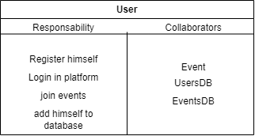

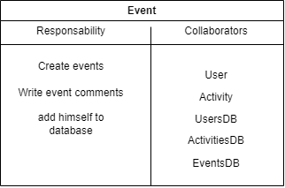

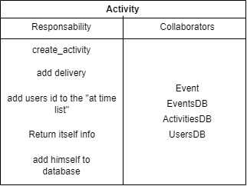

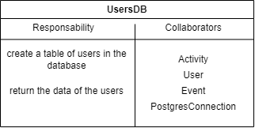

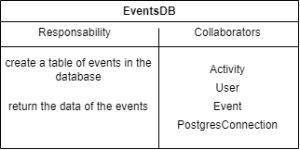

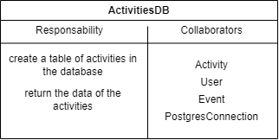

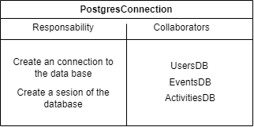

**Activity diagrams:**

**Registration and Login**

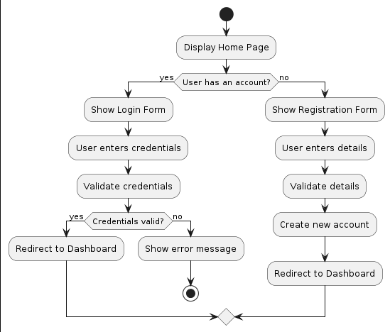

* Users start on the home page and choose to either log in or register.
* If they have an account, they enter their credentials and log in.
* If not, they fill out a registration form, create an account, and then are redirected to the dashboard.

**Event Creation**

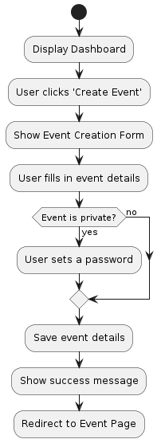

**Explanation:**

* From the dashboard, users can create a new event by filling out a form.
* They specify if the event is private or public.
* After saving the event details, they are redirected to the event page.

**Publishing Activities and Announcements**

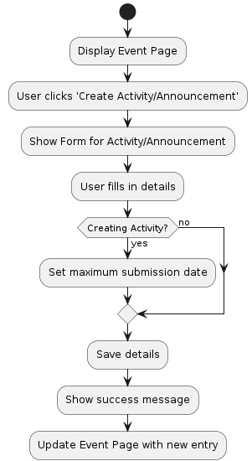

**Explanation:**

* On the event page, organizers can create activities or announcements.
* Activities have a maximum submission date, while announcements do not.
* After saving, the new entry appears on the event page

**Sequence diagrams:**

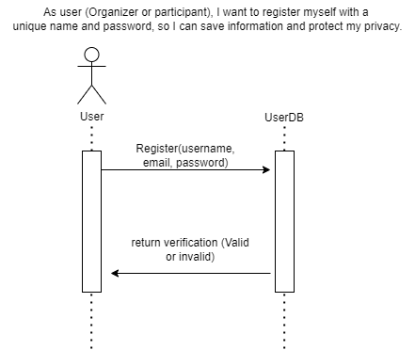

*(This diagram shows the user Register with a method in order to get a verification of the Database. It will return the verification. It will true if the user and e-mail are already registered, and it will false if it not, so the program can guarantee the unique existence of an user. )*

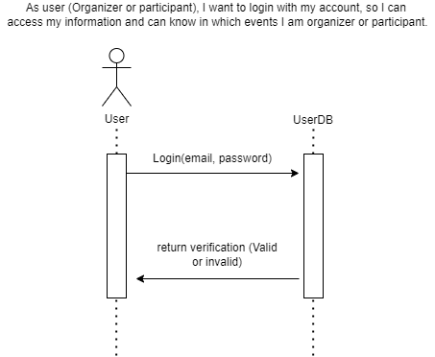

*(This diagram shows the user Login with a method in order to get a verification of the Database. it will return the verification. It will true if the username and password are correct, and it will false if it not, so the program can guarantee the privacy and security of the users. )*

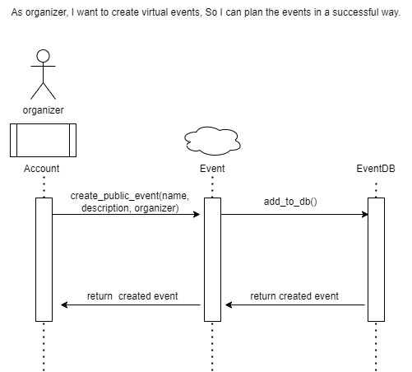

*(This diagram shows how an organizer can create virtual events with the method __init__() of the Event class, and it will be added to the Database)*

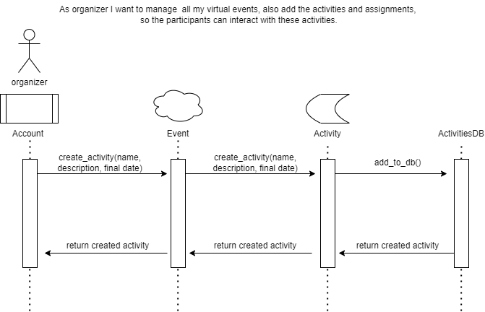

*(This diagram shows how an organizer can create activities of the virtual events with the method __init__() of the Activity class, when is created it will be added to the activities_list of an event)*

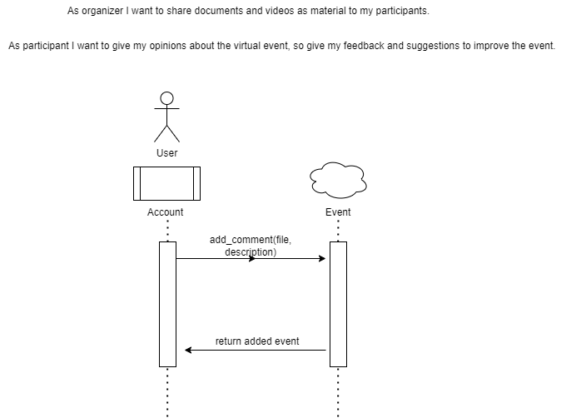

*(This diagram shows how an organizer can add support material with the method add_comment() so that the participants of an event can access it. This diagram achieve with two user stories)*

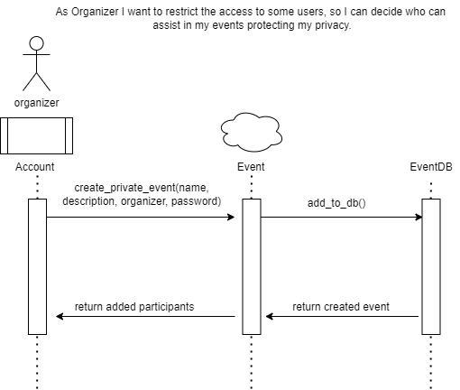

*(This diagram shows how the organizer can create an private event with password, restricting the access to not invited users)*

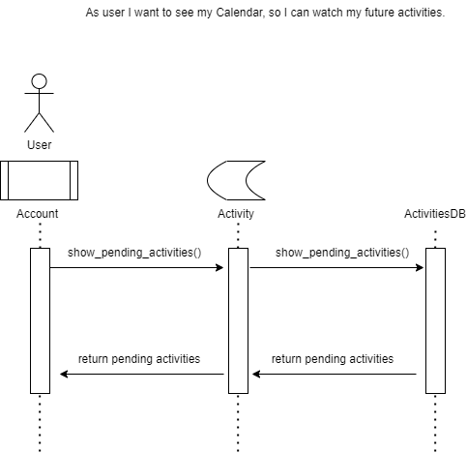

*(This diagram shows how the User can access the DashBoard to see his activities.*

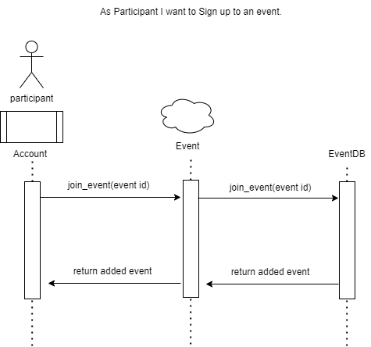

*(This diagram shows how a participant can sign up to a event with the join_eventt() method, he can watch it in the DashBoard, so it can be all the public events in the Database).*

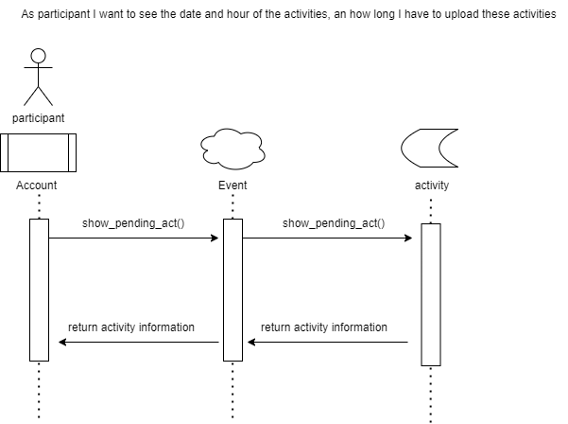

*(This diagram shows how the participant can watch the attributes of an activity of an event).*

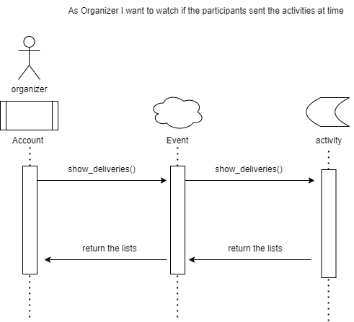

*(This diagram shows how an organizer can watch the deliveries of each participant that send their activities in a limit of time established by the organizer of an activity of an event).*

**State diagrams:**

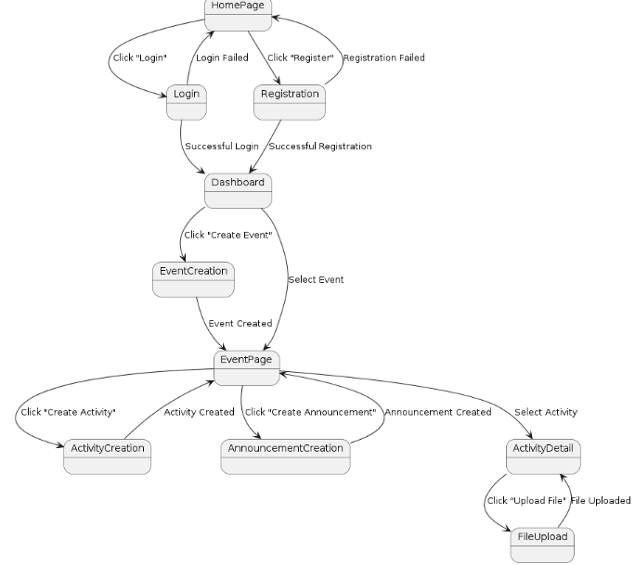

**Deployment diagram:**

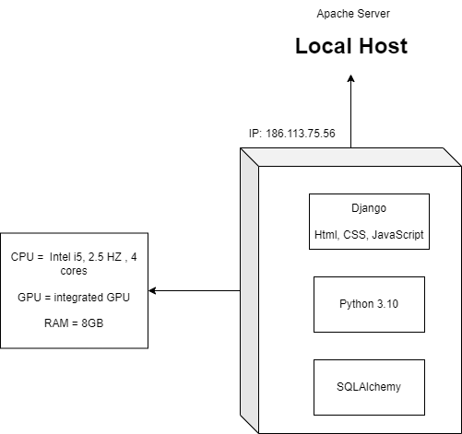

*(This diagram shows the physical requirements of the components of the server)*

**Explanation:**

The before data was calculated having this information for the program:

1. **Database Size Estimation**

***1.1.*  User Table**

Assuming 5000 users:

* username: 20 characters (20 bytes)
* id: 20 characters (20 bytes)
* password: 64 characters (64 bytes)
* email: 30 characters (30 bytes)
* registered_events: Avg. 10 events/user, ID 20 bytes: 10 * 20 = 200 bytes
* verified: 1 byte
* uploaded_activities_id: Avg. 20 activities/user, ID 20 bytes: 20 * 20 = 400 bytes
* participant_events_id: Avg. 10 events/user, ID 20 bytes: 10 * 20 = 200 bytes
* organized_events_id: Avg. 5 events/user, ID 20 bytes: 5 * 20 = 100 bytes
* Total per user: 20 + 20 + 64 + 30 + 200 + 1 + 400 + 200 + 100 = 1035 bytes.

Total for 5000 users: 5000 * 1035 = 5,175,000 bytes ≈ 5.18 MB.

***1.2. Events Table***

Assuming 2000 events:

* name: 30 characters (30 bytes)
* id: 20 bytes
* description: 100 characters (100 bytes)
* organizer_id: 20 bytes
* privated: 1 byte
* password: 30 bytes (average case)
* participants_id: Avg. 50 participants/event, ID 20 bytes: 50 * 20 = 1000 bytes
* activities_id: Avg. 20 activities/event, ID 20 bytes: 20 * 20 = 400 bytes
* comments: Avg. 10 comments/event, comment ~100 characters: 10 * 100 = 1000 bytes
* Total per event: 30 + 20 + 100 + 20 + 1 + 30 + 1000 + 400 + 1000 = 2555 bytes.

Total for 2000 events: 2000 * 2555 = 5,110,000 bytes ≈ 5.11 MB.

***1.3. Activities Table***

Assuming 10,000 activities:

* name: 30 characters (30 bytes)
* id: 20 bytes
* description: 100 characters (100 bytes)
* event_id: 20 bytes
* start_date: 10 characters (10 bytes)
* final_date: 10 characters (10 bytes)
* deliveries: Avg. 20 deliveries/activity, ID 20 bytes: 20 * 20 = 400 bytes
* at_time_list: Avg. 20 entries/activity, ID 20 bytes: 20 * 20 = 400 bytes

Total per activity: 30 + 20 + 100 + 20 + 10 + 10 + 400 + 400 = 990 bytes.

Total for 10,000 activities: 10,000 * 990 = 9,900,000 bytes ≈ 9.9 MB.

1. **Total Estimated Database Size**

**User table:** 5.18 MB

**Event table:** 5.11 MB

**Activity table:** 9.9 MB

**Total:** 5.18 MB + 5.11 MB + 9.9 MB ≈ 20.19 MB.

1. **CPU, GPU, and RAM Estimation**

***3.1 CPU and GPU***

A database size of approximately 20.19 MB, we don’t need significant CPU or GPU resources. A modern, entry-level CPU is okay.

***3.2 RAM***

Given the small database size, 4 GB - 8 GB of RAM should be more than enough to handle in-memory operations and run the database server efficiently.

**Recommendations**

**CPU:** Any modern entry-level CPU (e.g., Intel i3/i5 or equivalent AMD), with 4 cores and 2.5 Ghz

**RAM:** 4 GB - 8 GB.

**Storage:** An SSD with at least 50 GB for fast read/write operations and future growth.

**GPU:** Not necessary for this application; an integrated GPU is sufficient.

**Class diagram:**

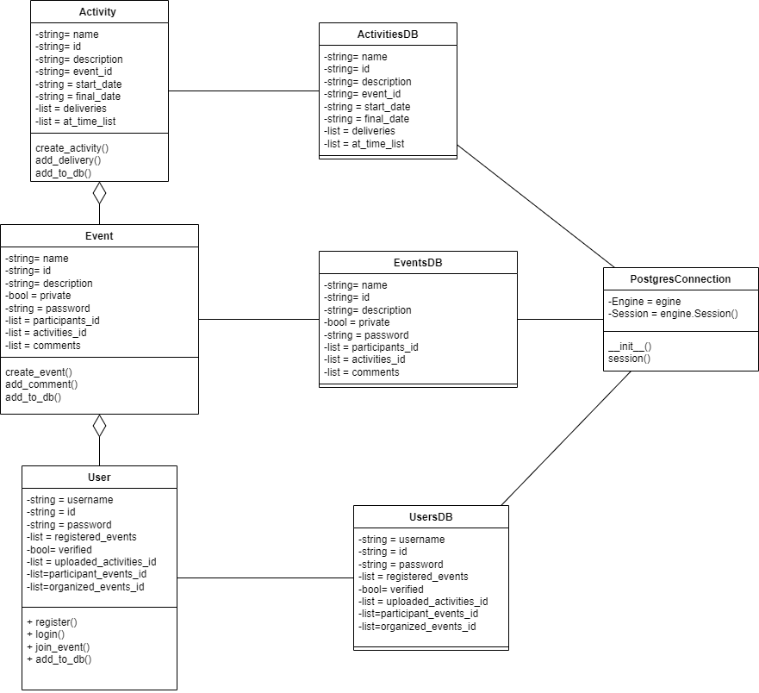

*(This diagram shows how the classes interact one each other)*

**Mockups**

1. **Home Page**

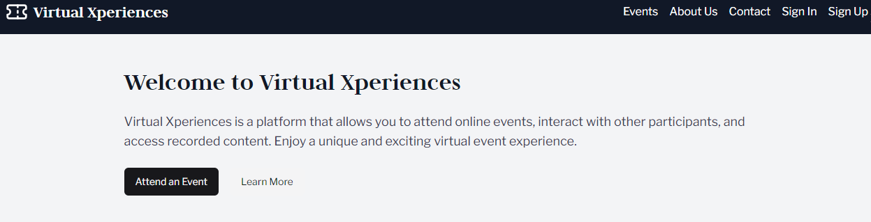

1. **Login**

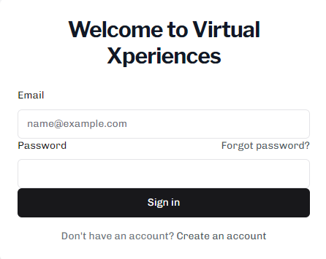

1. **Register**

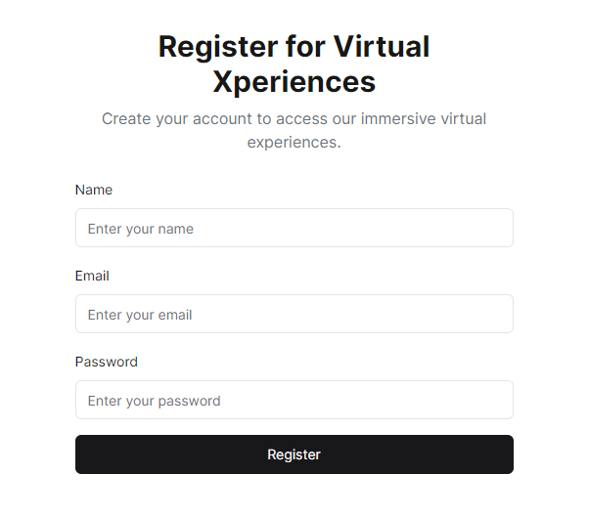

1. **Dashboard**

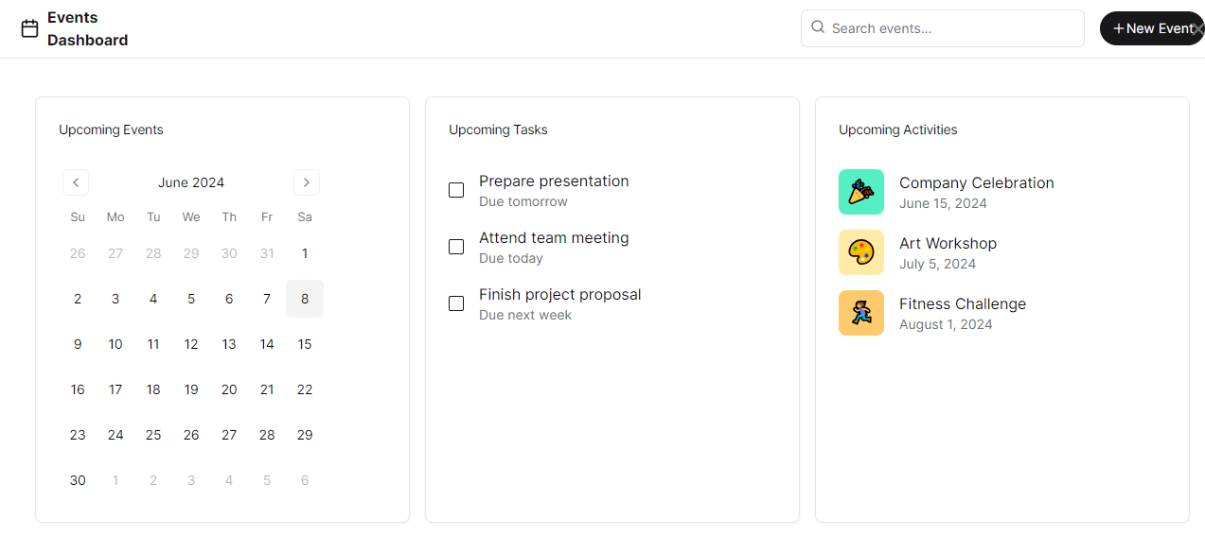

1. **Event page**

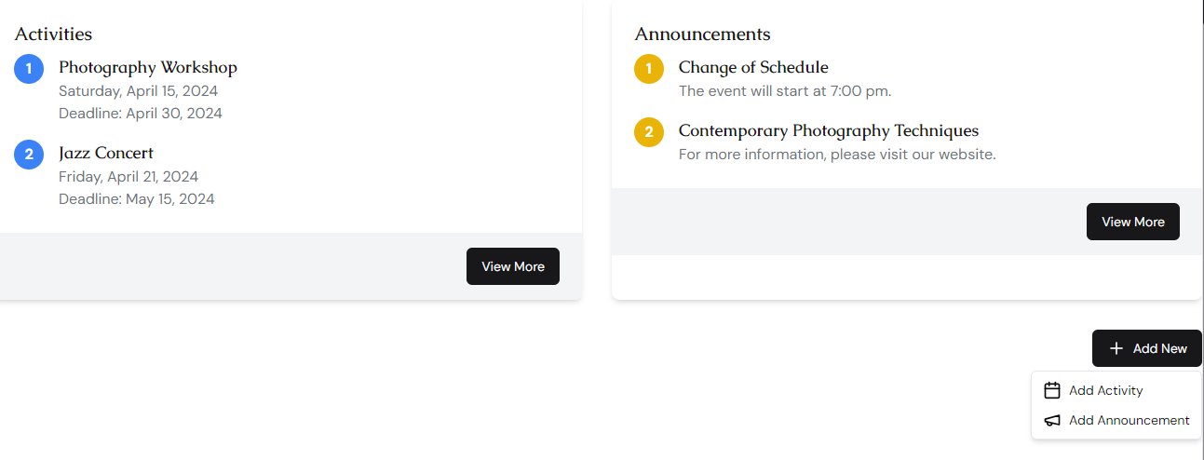

1. **Created event**

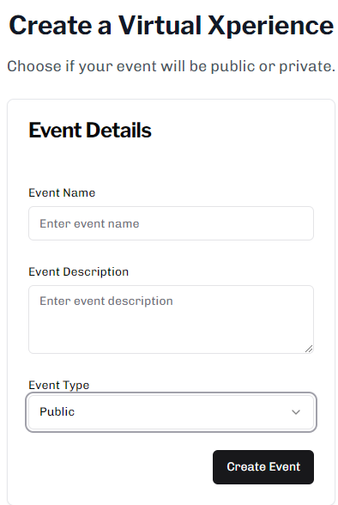

1. **Activity page**

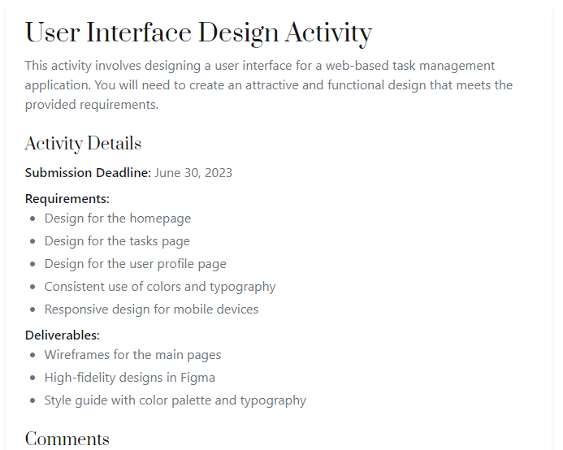

1. **Created activity**

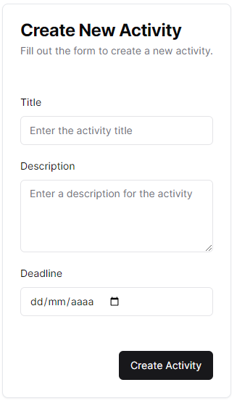

1. **Activity submission**

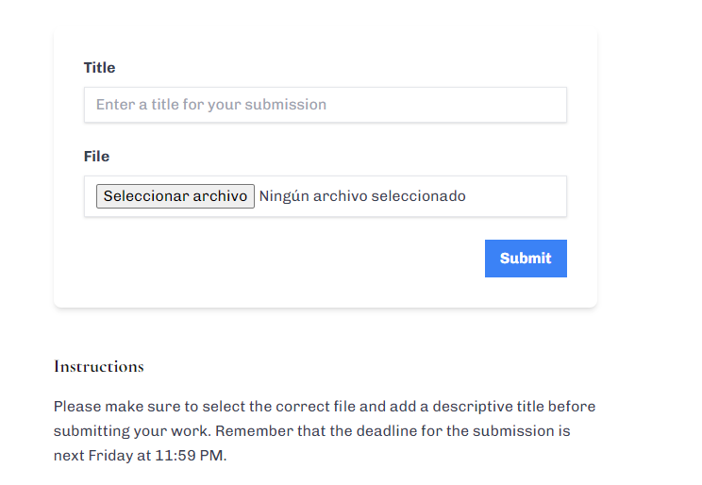

**Navigation Map:**

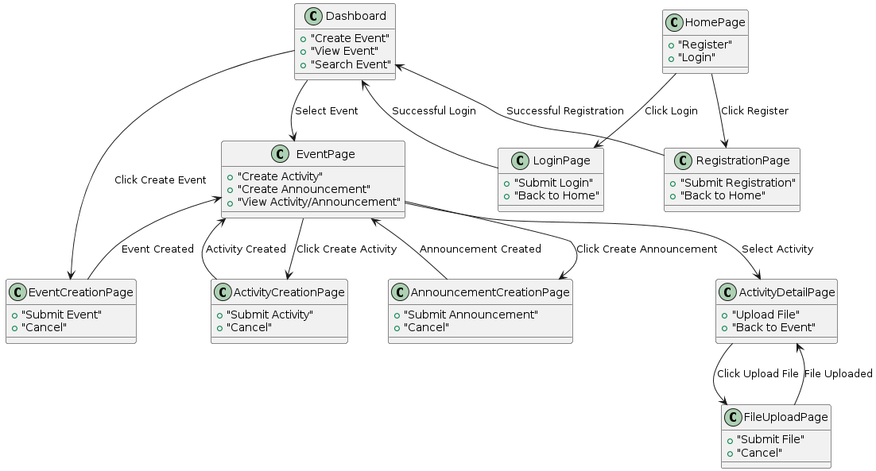

**URL_BASE: www.VirtualXperience.com**

**Home.py -> xperience/**

**Login.py -> xperience/login**

**Register.py -> xperience/register**

**Dashboard.py -> xperience/dashboard**

**CreatedEvent-> xperience/Createdevent**

**Search Event-> xperience/Searchevent**

**Event Page -> xperience/event**

**new Activity -> xperience/createdactivity**

**new announcement -> xperience/createdanou**

**announcement-> xperience/announcement**

**activity -> xperience/ activity**

**submit activity -> xperience/ submit**